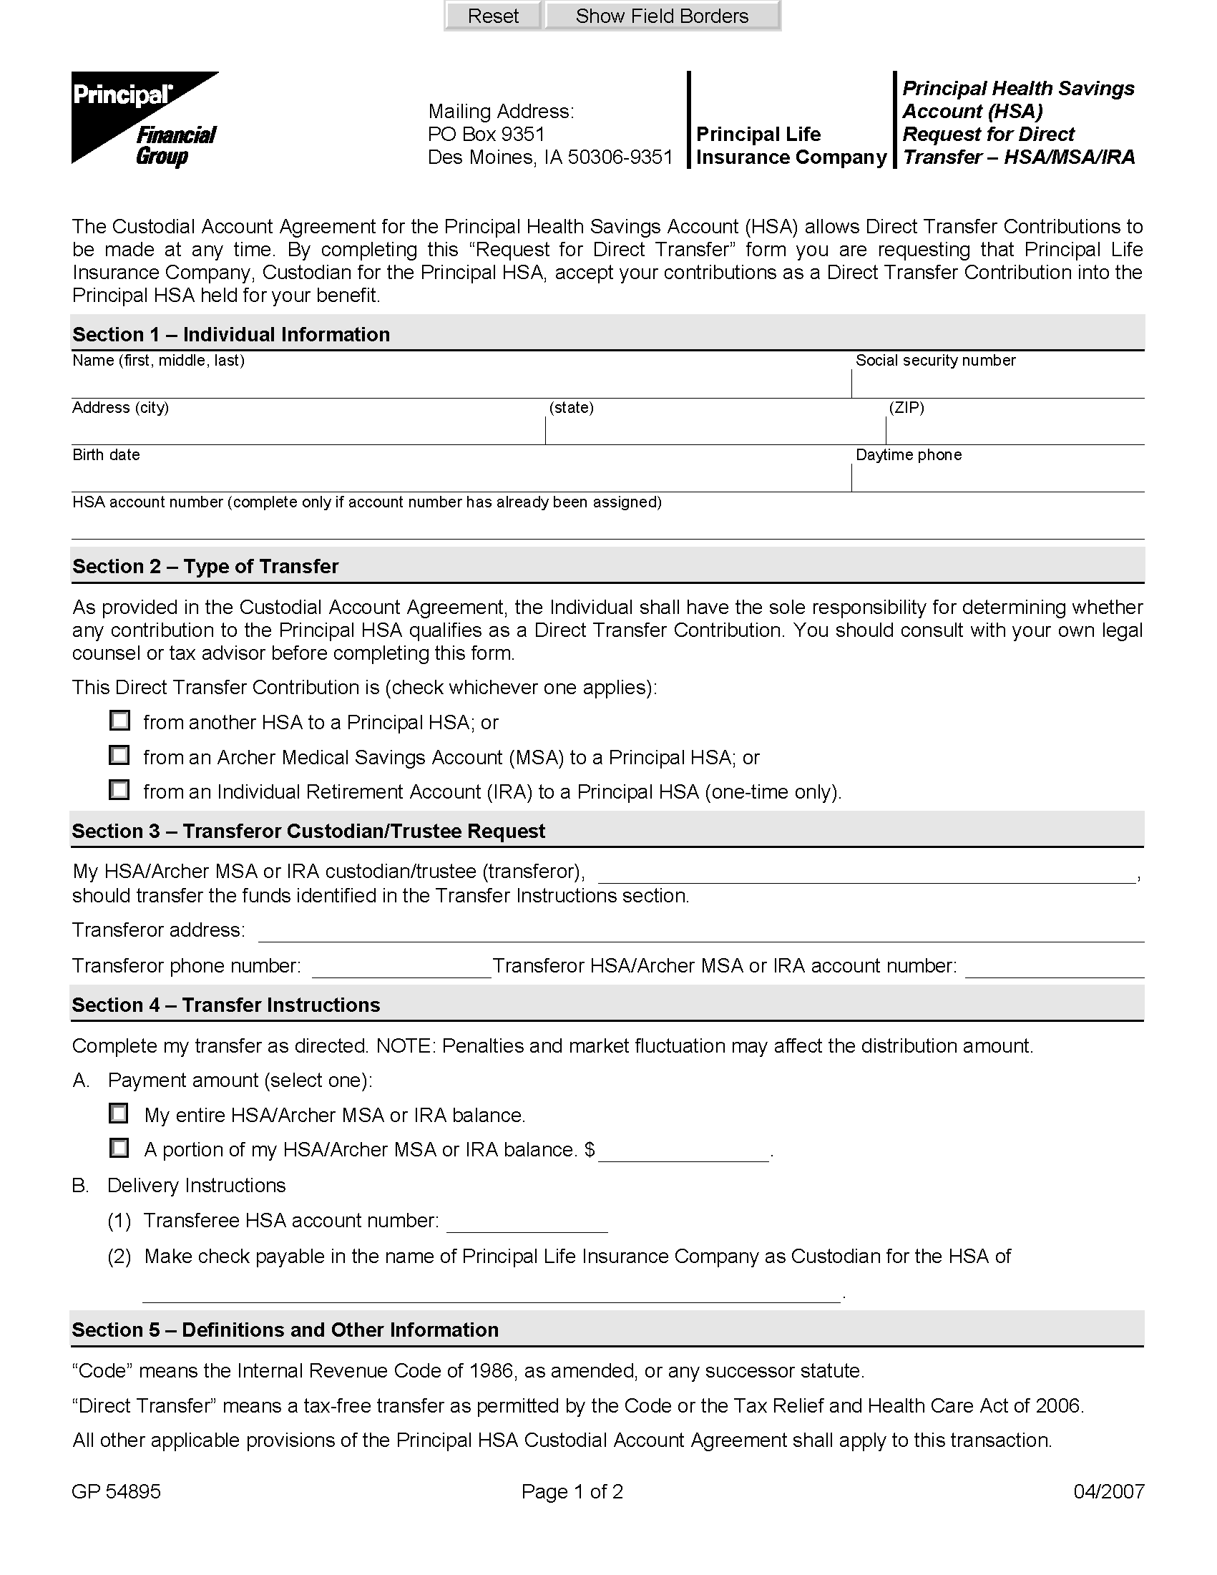
Authorization and
Designation of
Representative

Mailing Address:
Des Moines, IA 50392-0002

THIS DOCUMENT COMPLIES WITH FEDERAL AND STATE PRIVACY REGULATIONS.

1. | I authorize Principal Life Insurance Company to disclose information as described below.
 | a) | Please disclose information to:
 |  |  | Name: | Axiom Requisition Copy Service
 |  |  | Address: | 447 North Canal Road
 |  |  |  | Lansing, MI 48917
 | b) | Describe the information to be disclosed (check as applicable):
 |  | ☑ | Please disclose any and all information requested by the person or entity described above.
 |  | ◻ | Please disclose only the information specified below:
 |  |  | Description:
 | c) | Reason for the disclosure: |  |  |  | Amistadi vs. Mani
2. | I understand information may be used or disclosed as set forth by this authorization. This includes information created or received by Principal Life. This information may include, but is not limited to:
 |  | • Claim information  • Treatment records/office notes  • Alcohol or drug abuse treatment  • HIV/AIDS information  • Mental health information (excluding psychotherapy notes as defined by HIPAA) |  |  |  |  | • Hospital records  • Diagnosis  • Prescriptions  • Test results  • Benefit information
3. | If you are the representative of the person whose information is to be shared, describe the scope of your authority to act on the person’s behalf; for example, power of attorney, guardian, executor of estate:
4. | I understand that I may revoke this authorization at any time. The request for revocation must be in writing and sent to: Health Information Protection Analyst, Group Compliance, Principal Life Insurance Company, Des Moines, IA 50392-0002. I understand that a revocation is not effective if Principal Life has relied on the information disclosed to it. Such revocation shall not apply to any use or disclosure of my information specifically permitted by applicable regulations, and no action relating to this authorization shall be construed as creating any restriction on the uses and disclosures permitted without my authorization.
5. | I understand that any information disclosed under this authorization may be subject to redisclosure by the recipient, and no longer protected by privacy regulations.
6. | I understand that this authorization will be valid for 12 months following the date of my signature below.
7. | I understand that I am not required to sign this authorization form, but I must do so in order for the authorization to be valid.
8. | I understand that Principal Life will not condition enrollment, eligibility or the payment of a claim for medical, dental and/or vision coverage on the signing of this authorization.

GP 53231 Page 1 of 2 08/2005

Order No.: 01-16424-006

I have read the above language and do understand that my signing this authorization does relieve, release and forever discharge Principal Life, its successors, parents, representatives, affiliates, agents, officers, directors, employees, assigns
and | Donna Amistadi | , (“Releases”) from any and all causes of action, suits, controversies, claims,
demands and damages of any kind or character whatsoever that I ever had, now have or may have, both known and unknown, or that any entity claiming by, through or under me may have or claim to have against Releasees in any way related to the release of the above-referenced information by Releasees.
Donna Amistadi |  |  | 04/09/1970
Name of person who information is to be shared (please type) |  |  | Date of Birth |  | I.D. number
23 Wilmot Street , Fitchburg, MA
Address of person whose information is being shared |  |  |  |  | Phone number
Employer name |  |  |  |  | Account number
Employer address
Name of person or legal representative (if applicable)
Relationship of personal or legal representative to person whose information is to be shared
If signing on behalf of another, please attach the proper documentation that attests to your ability to sign (Court-stamped Letters of Appointment as Executor of Estate, proof of custody, power of attorney, etc.)
Signature of person whose information is to be shared (or person’s representative) |  |  |  | Date

Upon receipt of your signed authorization, a copy will be provided to you.

GP 53231 Page 2 of 2 08/2005

Order No.: 01-16424-006

